Conclusion
Q1. What is the most frequent genre in the dataset?
Drama genre is the most frequent genre in our dataset and has appeared more than 14% the times amoung 19 other genres. 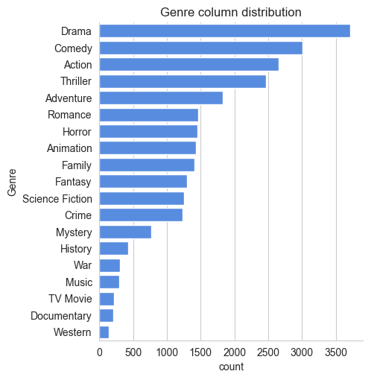

Q2. What genres has highest votes?
we have 25.5% of our dataset with popular vote(6520 rows) . Drama again gets the highest popularity among fans by being having more than 18.5% of movies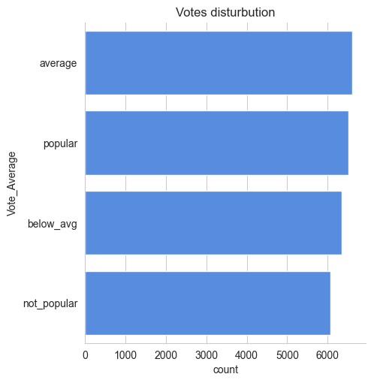

Q3. what movies got the lowest popularit ? what's its genre ?
The united states, thread has the highest lowest rate in our dataset and it has genres of music , drama 'war', 'sci-fic' and history;
 | Release_Date | Title | Popularity | Vote_Count | Vote_Average | Genre
0 | 2021 | Spider-Man: No Way Home | 5083.954 | 8940 | popular | Action
1 | 2021 | Spider-Man: No Way Home | 5083.954 | 8940 | popular | Adventure
2 | 2021 | Spider-Man: No Way Home | 5083.954 | 8940 | popular | Science Fiction

Q4. Which year has the most filmed movies?
year 2020 has the highest filming rate in our dataset. 